THE TITLE OF THE PAPER – EDITING INSTRUCTIONS IN MS WORD FOR WINDOWS
(Times New Roman font, 14 pt size, bold CAPital letters, centered alignment starting with the second space line of the page)

Name and Surname of the author(s) (Times New Roman font, 12 pt size, bold lowercase), scientific function and title, institution, e-mail: ……………@.........com (Times New Roman font, 12 pt size, lowercase without bold); (Between the title of the paper and the name(s) of the author(s) must be a space of two blank lines); alignment Justify

Abstract (style italic font, 11 pt size, bold, lowercase, align left)

To ensure an uniform style throughout the conference proceedings volume, all manuscripts must be written strictly in accordance with the instructions set out below. To assist the authors, the organizers provide this template file in MS Word. (Under the word: Abstract, after a space of one blank line, write the summary of the paper, up to 300 words, in Times New Roman font, 12 pt size, aligned at both edges (Justify).)

1. GENERAL INSTRUCTIONS (Times New Roman font, 12 pt bold, UPPERCASE; Arabic numbers are used for numbering); (The first title will be written at a distance of two blank lines below the abstract).

1.1. The text body (Times New Roman font, 12 pt bold, lowercase; decimal classification is used for numbering); (Both numbering of the chapters and of the subchapters is made from the beginning of the page, without any “Tab” space).

The text must fit into the writing surface of the page (160 × 242 mm).
For A4 format of the page, the page setup is: Top: 3,5cm; Bottom: 2,0cm; Left: 2,0cm; Right: 2,0cm; Gutter 0,00cm; Mirror margins. The pages will have a Header of 1,0cm and a Footer of 1,0cm, with different positions for the numbering of pages.
Paper editing will be made with the program Microsoft Word 2003, or other compatible with it.
The paper is limited to 6 pages.
Pages will NOT be numbered.

1.2. Font type, letter size and spacing

The writing of the paper must be done using Times New Roman font.
The body text will be written at one space line with Times New Roman font, 12 pt size, aligned at both edges (Justify), and any highlight from the text will be made with italic style, 12 pt size.
First line of the paragraph must be written at one Tab space (that is with the displacement to the right of the text with 12 characters)
The following spacing rules must be applied:
- between the title of a chapter and it’s first subchapter (in the case it follows next) must be a space of one blank line.
- between the title of a chapter or a subchapter and the first line of text, must be a space of one blank line.
- between paragraphs (chapters) must be a space of one blank line.
- in the text body, at the end of the line, depending on the case, words shall be split into syllables so that no blank space will remain unoccupied.

2. THE TEXT STRUCTURE

2.1. Equations

Equations will be written with the “Equation Editor” toolbox. The numbering of the equations will be made with Arabic numbers between round parentheses and aligned right in the page.
$g_{F}=\frac{S}{A}⋅\text{100}$ [%] (1)
where: $S$ = plane surface affected by cracks, cm²;
$A$ = total measured surface, cm².

2.2. Figures

There must be a space of one blank line between the last line of the text and the figure, and between the name of the figure (which is written right below the figure) and the first line of the text too.
The figure and the caption with its name are aligned central (Figure 1).
The figures will be made electronic and they will fit as mentioned above. The number of the figure will be written with Times New Roman font, 12 pt bold, lowercase, and the legend with the same type of characters, but regular, without bold.

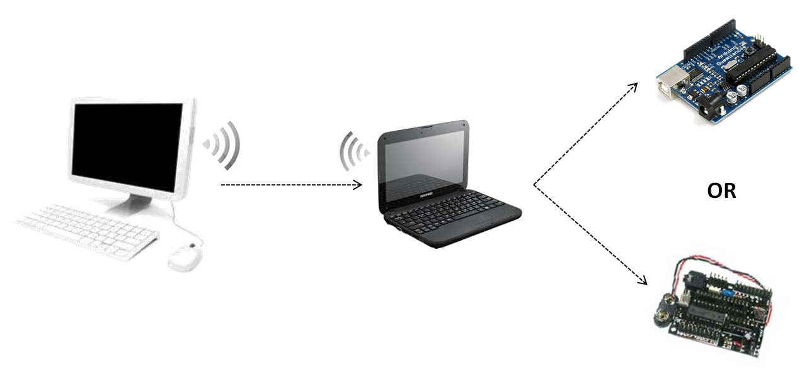

Figure 1. Name of the figure

2.3. Tables

The tables will be made with the necessary lines and the text will be written with Times New Roman font, 12 pt regular. The number of the table, its title and the text from the table head will be written with Times New Roman font, 12 pt bold, lowercase; the rest of the text in the table will be written with regular characters, 12 pt without bold.
There will be a space of a blank line between the last line of the text body and the title of the table (Table 1), same for the last row of the table and the first paragraph line of the text body.

Table 1. Name of the table
Mark | LOW | MEDIUM | HIGH
Severity level, , [%] | 0,4 | 0,7 | 1,0
The opening of the crack on the field, d, [mm] | d ≤ 5 | 5 < d ≤ 20 | d > 20
The opening of the crack on the laboratory model, d, [mm] | d ≤ 1 | 1 < d ≤ 4 | d > 4

2.4. Observations

The figures and the tables from the papers will be properly highlighted and drawn up with clear lines (of proper thickness), so them will not degrade by copying (printing).
The text body will be arranged properly in order to show only once the tables, the figures and the formulas.
References will be noted in square brackets and formulas in round parentheses.

3. CONCLUSIONS

Conclusions should summarize the most important statements of the paper, and also the author(s) point of view regarding the practical implications of the study results.

REFERENCES

The bibliography will be written with Times New Roman font, 11 pt size, following the next indications:
- after the last line of the conclusions text body, at a distance of one blank line, it will be written REFERENCES, with bold UPPERCASE, aligned left;
- there will be a space of one blank line between the word REFERENCES and the first bibliographical reference;
- numbering of the references will be made with square brackets;
- name and surname of the author(s) will be written with UPPERCASE, without bold;
- the titles of the references will be written with italics, without bold;
- the publishing house and the locality of the publication will be written with regular letters; the year of the publication will be written with bold numbers;
- References will be written on the entire width of the page;
- if the data from a bibliographical reference extends on more lines, the second or the third line will be aligned below the name of the first author from that reference;
- there is a space of one blank line between references;
- in the case of the papers that will be indicated as appeared in different journals, we recommend to use the same procedure as for the references. In addition, it will be written with bold numbers: volume number and page number on which extends the study reported in that journal.

[1]. | V. GIONCU, M. IVAN, Teoria comportării critice şi postcritice a structurilor elastice, Editura Academiei, Bucureşti, 1984.
[2]. | A.MAUTHE, D.Hutchison, G.Coulson and S.Namuye, “Multimedia Group Communications Towards New Services”, in Distributed Systems Eng., vol. 3, no. 3, Sept. 1996, pp. 197-210
[3]. | V. I. ARNOLD, Metodele matematice ale mecanicii clasice, Editura Ştiinţifică şi Enciclopedică, Bucureşti, 1980.
[4]. | *** “COSMOS/M – Finite Element System”, User Guide, 1995.

